Name _________________

Computer 8 - Excel Labeling Quiz

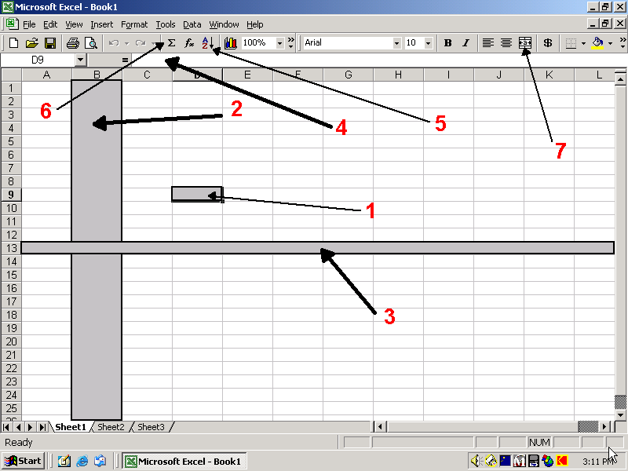

**Directions: Write the name of each thing or what it does.**

1. _____________________________
2. _____________________________
3. _____________________________
4. _____________________________
5. _____________________________
6. _____________________________
7. ________________
8. What is the name for something you make in Microsoft Excel? ________

________________________________

1. Where is the best place on the screen to make changes? _________

________________________________